ULTRASONIC THICKNESS MEASUREMENT REPORT
Company/Client: NCOC N.V. |  |  |  |  | Project: ESKENE WEST KARABATAN |  |  |  |  |  |  |  |  | Location: KUT
Line No/Tag No:  A1-5300-DW-029-3”-A05-WN |  |  |  |  | Component examined |  | Material |  |  |  | Stainless Steel |  |  | Probe sensitivity calibration
Procedure No:  GOST 28702-90  QP-11-UTT-Q01 Rev 01 |  |  |  |  |  |  | Día X Nominal Thickness |  |  |  | 3” x 3.05 mm |  |  | Probe S/N |  |  |  | 1058416
 |  |  |  |  |  |  | Operating Temp |  |  |  | 18º C |  |  | Angle |  |  |  | 0º
Manufacturing Code/Acceptance Standard:  ASME B31.3 / Client Specific |  |  |  |  | Reference Calibration Block Details |  | Block |  |  |  | Step wedge  CS 1018 |  |  | Frequency |  |  |  | 5 MHz
 |  |  |  |  |  |  | Range |  |  |  | (6.25-25 mm) |  |  | size |  |  |  | 11 mm
Method: Contact |  |  |  |  |  |  | Accuracy |  |  |  | 0.025 mm |  |  | Crystal |  |  |  | Dual
Surface condition: not coated |  |  |  |  |  |  | Temperature |  |  |  | Ambient |  |  | Reference sensitivity |  |  |  | 2nd backwall reflection to 80% FSH
Couplant: Gel |  |  |  |  | Correction factors |  |  |  |  |  | 2% of the thickness |  |  | Scan Sensitivity |  |  |  | +6 dB
S. No | Equipment/  Material Name |  | Manufacturer |  |  |  |  | Serial No |  |  |  | Calibration certificate No |  |  |  | Calibration Expiry date
 | A-scan UT |  | OLYMPUS DL-38 |  |  |  |  | 171421601 |  |  |  | A-01-0552 |  |  |  | 02-04-2019
 | Step wedge calibration block |  | OLYMPUS |  |  |  |  | 145414 |  |  |  | - |  |  |  | -
Job description:
UT Lamination has been carried out on 3” line on distance 100 mm from the end of the pipe.
Legend: -
INSPECTION PHOTOS & RESULTS
No |  | Item description |  |  |  | Nominal Thickness (mm) |  |  | Min (mm) |  |  |  | Max (mm) |  |  |  | UT-Lam Result
1 |  | FBW-01 |  |  |  | 3.05 |  |  | 3.08 |  |  |  | 3.18 |  |  |  | No lamination
2 |  | FBW-02 |  |  |  | 3.05 |  |  | 3.1 |  |  |  | 3.2 |  |  |  | No lamination
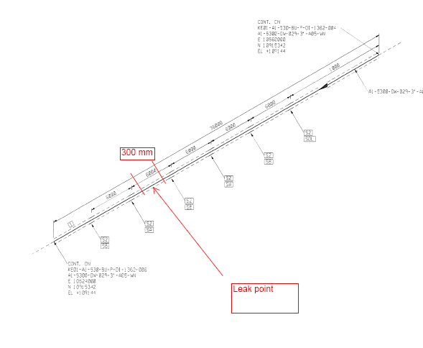
FBW-02
FBW-01
FBW-02
FBW-01
Examined by  UT L II cert. No 048  expiry date 01.03.2020 |  |  |  | Name: Kosmukhambetov Rustembek |  |  |  |  |  | Signature:............................................ |  |  |  |  | Date: 25.04.2018
Approved by  UT L III cert. No 1A123/15  expiry date 29.02.2020 |  |  |  | Name: Shundryk Ihar |  |  |  |  |  | Signature:............................................ |  |  |  |  | Date: 25.04.2018
Client Representative: |  |  |  | Name:…………………………………… |  |  |  |  |  | Signature:............................................ |  |  |  |  | Date: …………………………

